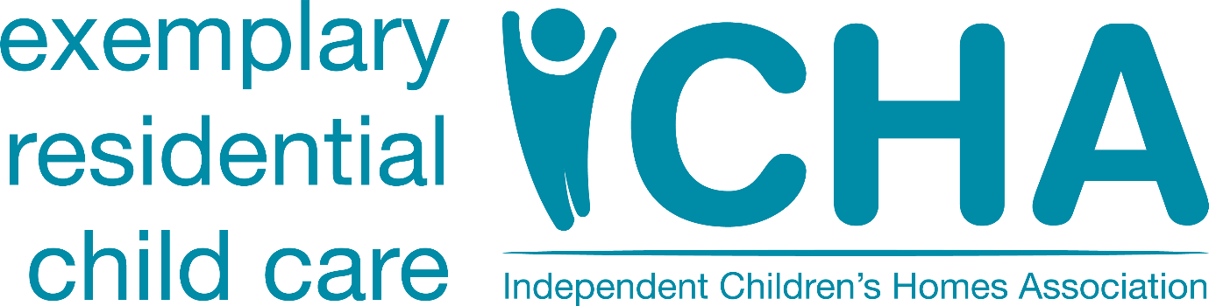
ICHA Media release
ICHA welcomes the Commons Education Committee announcement of an inquiry into children’s homes
19th February 2021
Today, Robert Halfon the Chair of the Commons Education Committee announced an investigation into children’s homes stating that: “As part of the Committee’s unerring focus on supporting disadvantaged groups, this inquiry will get to the bottom of why children and young people living in children’s homes are facing such an uphill struggle to get on in life”. The Independent Children’s Homes Association welcomes and supports such scrutiny of the residential child care sector together with the focus on the continued use of unregulated provision but I am left wondering ‘why now’? In a few days the long-awaited care review starts and surely Josh MacAlister’s task is to conduct just such an enquiry but, rather than concentrating on what is one small part of the public care system centering it on the whole system.
That being said, the focus of the Committee’s enquiry on what can be done to improve outcomes is welcomed. The system itself is in disarray. All to often children come into homes because they have been failed at every step of the ‘care journey’. Their poor outcomes are known to be attributable to adverse childhood experiences, late intervention, use of unregistered provision and frequent moves. What we do know is that the quality of care they receive in registered children’s homes is high with 80% measured by Ofsted as being good or outstanding and only 2% (yes that is too many) inadequate. Providers would welcome the introduction of impact measurement across the sector, indeed many are looking to implement the fully peer reviewed and RCT tested CANS model of impact measurement www.outcomesofcare.com/tcom-england-cans .
We know that homes have good outcomes when used earlier to help children step down into foster care. We know that innovative thinking such as ‘No Wrong Door’ contributes to better outcomes and we know that around the country, many care providers ease the burden on public services through the provision of education and therapeutic services.
Yes, the Chair, is spot on in his recognition that we need to close the door on children being placed in unregulated provision once and for all. As the Committee’s enquiry is launched I know the registered children’s home sector will be pleased that the Government has announced that such provision will be banned for those under 16 from September 2021. In the same announcement the Government stated that they would shortly be launching a consultation as to what the national standards should be for older children going into 16+ provision. Our belief is that it is imperative that these are brought into operation as soon as possible.

Peter Sandiford
CEO
Peter.sandiford@icha.og.uk
Tel: 07597 982 533

Notes to Editors

The Independent Children’s Homes Association Ltd (ICHA) is the voice of providers of residential child care services and resources across England and Wales. We are a Not for Profit Limited Company.
ICHA’s Vision: ‘Exemplary Residential Child Care.’
ICHA’s Mission: ‘A member-led organisation driving excellence in residential child care through innovation, collaboration and sector leadership’.
ICHA represents both large and small providers. Some members have just one home whilst others have many homes across a wide geographic area.
Peter Sandiford
CEO of ICHA
07597 982533

